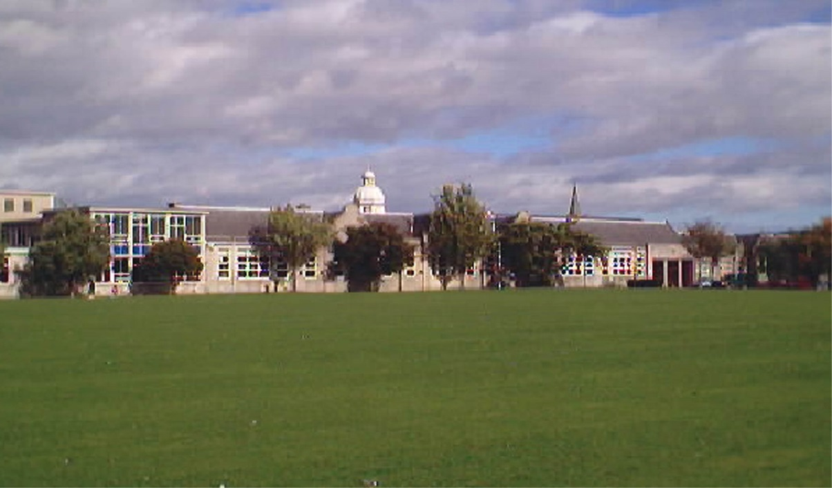

Term 1 Newsletter 2014-2015
NEWSLETTER OCTOBER 2014

Message from Rector………….

Welcome to our first newsletter of session 2014-15. It’s certainly been a busy term as I’m sure you’ll see reflected in this publication.

We were pleased to be able to start with good news about exam results this session which have again shown improvement in several areas. My warmest congratulations go to all the pupils who worked so hard – and my thanks go to all the teaching staff here at the Academy who show such dedication, commitment and support to the pupils in their care.

We have warmly welcomed some new additions to our Inverurie Academy team and I’m sure you will come to put faces to these new names over time. I am delighted that the Senior Leadership Team have been joined by Ms Lee Menzies and Mrs Pauline Fraser as Depute Head Teachers. I was also very pleased indeed to be able to welcome our two new Principal Teachers - Ms Jill Merchant in English and Mr Craig Paterson in Humanities. Other teachers who have been warmly welcomed as new additions to our school community are: Mr Mike Blackburn and Ms Lyndsey Kavanagh in Business and IT, Ms Rebecca Conn in Music, Mr Stewart Paterson in Physical Education, Ms Kirsty Wilson in Home Economics, Mr Ben Kirk in RMPS, Ms Fiona Toet in Maths, Mrs Fleur Capocci in English and Ms Bethany Sinclair in SfL. A special mention must go to Mrs Shona Lees, who is the Inverurie Pupil Support worker and covers all primary schools as well as our own pupils. More new faces will join us in the coming weeks and months, and we look forward to welcoming Ms Sian Phillips to the SfL team next term.

I hope you enjoy reading this term’s newsletter and that the October break has better weather than the rain and wind battering my window as I write this in the last week of term!

I hope the children’s break from school provides time for family and friends to enjoy each other’s company.

Linda Evans
Rector.

Blythewood Visit - Taylor Chapman, Thomas Mackie, Cole Goodwin

When we went for our induction days was entered a competition for naming the new Blythewood care home and the winners would receive a prize so we entered just like a lot of S1 pupils.

We thought long and hard about our name but we had been told there was a view of Bennachie so we thought to make our name quite short, simple and snappy so it was easy to remember and to know so that’s how we came up with the name Bennachie view.

We were just ecstatic when we found out our name was chosen to name the new care home we were also just really, really surprised because we never thought that our name would ever be chosen in a million years but it was!

With our prizes that we received we were just grateful, we each received 20 pounds and for the class we got 40 pounds. For the class we are going to choose a cuddly toy mascot! For our individual prizes we are undecided at the moment.

We have really enjoyed being part of this competition

Humanities Faculty – Mr C Paterson, PT Faculty

Hello, my name is Mr Paterson and I am the new head of the Humanities faculty. In the past I have worked at Ellon Academy and at Mackie Academy in Stonehaven. I teach History, which is not just my subject but my passion. I am very keen to support the development of History at Inverurie Academy with extra-curricular activities and trips. In the near future I will be running an activity called ‘Mr Paterson’s Hardcore History’ which will involve a series of lunchtime History lectures on subjects that don’t make it into the curriculum.

My first term at Inverurie Academy – Mrs P Fraser, Depute Rector

I would like to start by taking this opportunity to thank the pupils, staff and parents/carers I have met so far for making me feel so welcome in my first term at Inverurie Academy. The commitment of everyone in the school community to both curricular and extra-curricular activities definitely contributes to the very positive and welcoming ethos in the school!
Earlier this term, I introduced the new “Show My Homework” web-link to all pupils at assemblies and have encouraged them to see this as a tool to help them with their learning. We hope that parents/carers are also finding this tool useful for supporting their child/children at home. (We will be asking for feedback later in the session). The weekly reports we receive from “Show My Homework” are certainly showing that there has been a steady increase in the use of it each week so far.
One of the most enjoyable things about working in school is the opportunity to celebrate success with our young people. I am now introducing a new ‘Achievement Record Slip’ for pupils and staff to use to inform us of achievements from all of the activities our young people participate in (both in and out of school). This will hopefully capture an increased level of information and allow us to have even more opportunities to celebrate success via assemblies, our ‘Wall of Fame’, bulletin notices, PSE, etc. A copy of the slip will also be put onto the school website in October for parents/carers to use too; so please feel free to fill in the details and post or email it to the school office. The slips will also be collated and used by the young people for recording achievements in their profiles later in the session.
My first term here has been both busy and enjoyable. I wish everyone a restful October break and look forward to Term 2!
Pauline Fraser (Depute Rector)

Free School Meals

A good number of Inverurie Academy pupils are entitled to Free School Meals. If your family is in receipt of housing or council tax benefit you will not need to submit a separate application form – council officers will write to you to confirm your entitlement. If your family is not in receipt of housing or council tax benefit, you can obtain an application form for free school meals by contacting your local benefits office, calling 08456 080149, emailing benefits@aberdeenshire.gov.uk, or visiting www.aberdeenshire.gov.uk.

School meals are healthy and nutritious, and as we move into the colder months it is more important than ever to make sure your child is well nourished. Information on menu options can be found here:

http://www.aberdeenshire.gov.uk/schools/school_meals/academy.asp

Clothing Grants

If your family is in receipt of housing or council tax benefit, you may be entitled to a clothing grant of £50 per year to help with the cost of school uniforms. In this case, council officers will write to you to confirm this. If your family is not in receipt of housing or council tax benefit, you can obtain an application form by contacting your local benefits office, calling 08456 080149, emailing benefits@aberdeenshire.gov.uk, or visiting www.aberdeenshire.gov.uk.

It’s really important that all pupils adhere to our uniform code. For full details of what is and is not part of school uniform, please refer to the uniform leaflet that was issued earlier this session. If this has been misplaced, our Guidance team will be happy to provide advice.

Guidance Team

Selbie House pupils were disappointed to hear of Miss Lloyd’s ill health at the start of this session, but have been well looked after by the other members of the Guidance team in her absence. We are delighted that Miss Lloyd is well on the road to recovery, and know that she is grateful for all the good wishes that have been sent her way.

Norovirus

As part of this year’s norovirus seasonal awareness campaign, NHS Health Scotland has sent information to the school. If you or your family have norovirus, or norovirus symptoms, please stay at home. NHS advice is to remain at home for 48 hours after symptoms have stopped in order to prevent it spreading. We have leaflets that we can provide – please contact the school office if you would like to see one. Alternatively, more information can be found at www.nhsinform.co.uk/norovirus or through contacting your GP surgery.

Child Protection

All members of staff have a shared responsibility to ensure that every pupil remains safe and well. Our attendance monitoring policy and process is a key part of this. Pupils are be registered in every class during the day. You will be notified (usually by text message) if they have been marked absent. If this happens, please call the school office as soon as you can to find out more.

Inverurie Academy works in clear groupings or staff teams. There is a reporting process within each, and within this a clear channel for concerns about a child to be shared. Ms Lynch is the school Child Protection Officer, and is responsible for making sure that any concerns raised are dealt with appropriately.

If you have a worry or concern about your own son or daughter, or another pupil of our school, please contact the relevant Principal Teacher of Guidance in the first instance. If you are not sure which Guidance Teacher to speak with, the school office will be able to let you know. By keeping in regular contact we can work together to make sure that our pupils are happy, safe, and able to reach their potential.

Fringe Trip - Franny Schlicke 6S

This August Scotland’s capital hosted close to 50,000 performances of over 3,000 shows, making the 2014 Edinburgh Festival Fringe the greatest arts festival the world has ever seen. And for the third year running, I was one of the pupils on the academy’s annual Fringe Trip. Pulling out of Inverurie before 8am, we packed four shows (of the 3,193 on offer) into our day in Edinburgh.

First we piled into the Underbelly to see Feral by Tortoise in a Nutshell, an extraordinary performance in which puppeteers built a miniature town before our very eyes which they proceeded to bring to life. Every movement was caught in film, live, and projected onto a screen above. The homemade paper characters inside their cardboard buildings told an amazingly commanding, heart-wrenching story of a community transformed and ultimately destroyed by the invasion of big business.

We grabbed lunch and then came our next show – Echolalia, by Jen McArthur. A one-woman clown performance illustrating life with Asperger’s, the show was both funny and touching. It also called out for audience participation – and since we were in the front rows, that meant us! (I was given two pieces of shortbread…)

The third show was perhaps the best of the day – of my three trips down to the Fringe, it was surely my favourite yet. The Bunker Trilogy: Morgana was by Jethro Compton Productions, and set in WW1 trenches. After showing our tickets we had to stoop to walk into a tiny wee room, the four walls lined with benches, the floor with dirt and sawdust, where three men sang Christmas carols and greeted us, never out of character. The young soldiers were friends desperate for distraction from life in the trenches – singing, dancing, playing cards, telling stories… Then the mysterious Morgana wanders into their lives off no-man’s land. Based on Arthurian legend, the show was brilliant, filled with laughter, fantastic singing and an utterly compelling story. It was hugely moving as well, all the more so for being performed in such a tiny space with the audience and actors so close to one-another. Seeing it at HMT in Aberdeen wouldn’t have been the same!

Finally, we powered across Edinburgh to our final venue where Chris Goode performed Men in the Cities. An immensely powerful piece, Goode stood at a microphone to recount fragmented tales of lives across London – all belonging to quite separate individuals, but all revolving around the murder of Lee Rigby. The show was provocative and challenging – maybe quite overwhelming, but certainly very popular. And Goode is a three-time Fringe First winner.

There were the seemingly limitless street performances too on the Royal Mile, which we had a chance to glimpse between shows – dancers, singers, acrobats, juggling fire-eating unicyclists…

The day was non-stop and utterly fantastic, and I’m extremely grateful to Mrs Campbell for organising it. I only wish she’d let me come back next year!

Science Club – Franny Schlicke 6S

If you’re stuck for something to do on Wednesday lunchtime, you could do worse than torture a jelly-baby, blow a giant bubble or explode some food… all in the name of science!

Science Club runs in Lab 3, 12.45-1.15pm every Wednesday, with the aim of having fun while learning about the impact physics, chemistry, biology and maths have on our everyday lives.

So far this session, we’ve had hands-on experiments involving huge bubbles, made a bit of a mess with cornflour, checked the size of a squid’s eye (a size 5 football, since you ask!) and built a fully functioning camera. While we were doing that, we were investigating surface tension, density and even the electro-magnetic spectrum in a really painless way!

We always welcome new members, regardless of whether you’re a keen scientist or not. Check the bulletin for our weekly programme, or just ask Ailie (Maconochie), Genni (Brown) or me for more information.

Mind you, if you’re of a nervous disposition, you might want to avoid Screaming Jelly-Baby Week

So you want to be a Doctor’ Day - Caitlin O’Shaughnessy

A question such as ‘do you want to be a doctor’ cannot be answered in a simple yes or no fragment, well not if you want it, like really want it. Want it so bad you are prepared to give up your whole life for it, suffer the pain of someone dying because of a decision you made in a spur of the moment and endure shifts that can last days. What I learned in this amazing experience is just that. You cannot go into this profession unless you want above all else and it is not a decision that can be taken lightly.

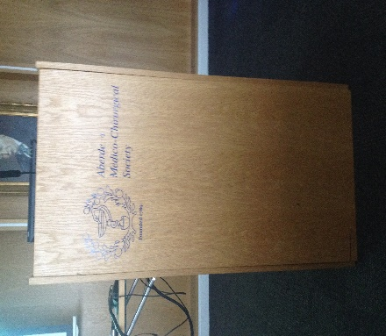
Sophie Stewart and I arrived at the Suttie Centre for Teaching and Learning in Healthcare at five minutes past nine in the morning, which was around forty minutes before we were meant to be there. However, to our surprise Thomas McFarlane and Scott Wood were already there dozily sitting in at that time looked like some very welcoming chairs so we sat and waited… And waiting… And waited… Until what seemed like a lifetime later we got to move to the conference room where we got a hospitable welcome and introduction to what we would be doing that day.

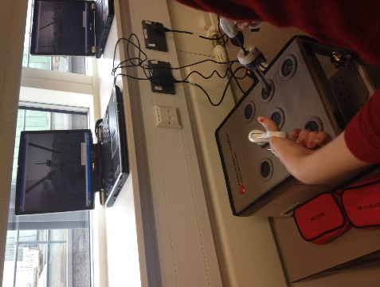
Subsequently, we moved to our first workshop called, ‘Testing Your Surgical Skills’ where we were given the opportunity to test whether or not we had the dexterity to become a surgeon. Personally, this was my favourite workshop as I aspire to become a surgeon myself. We tried out some key-hole surgery in which we received a box with many holes in it, we then got little clippers that we poked through the holes. We could not see through the box so we had to look at a computer screen that showed us what was going on inside the box as there was a small camera inside.

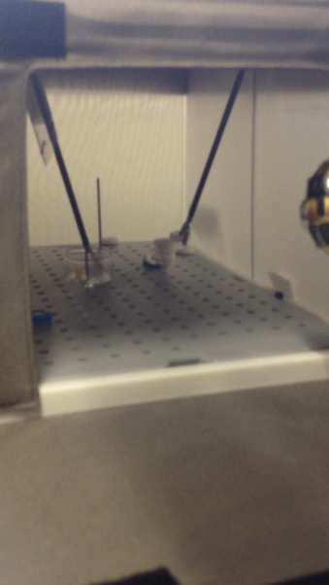
Inside of the box were many objects, we had Polo’s that we had to place onto pols and rubber bands that we had to use to connect two pols together. Everyone seemed to react in either one of two ways, either get pent up with stress and frustration or silently concentrate on the screen. I, personally, was more of the silent concentration type and I found it strangely calming and very rewarding once I finally got a stubborn Polo onto a metal stick.

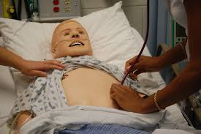
After that wonderful experience we swiftly moved onto the Trauma part of the day. When we were there we learnt many things about the A, B, C, D, and E’s of Trauma. The man who taught us was very witty and amusing which made the subject very exciting and interesting. He included us in demonstrations such as he stopped the blood flow from our wrist to our hands by pressing on two points on our hands. He also showed us what they do to trauma patients who aren’t responsive. We then had a go at examining and trying to diagnose the Sim Man which really tested how much we pay attention to detail.

After that we had lunch with the Med Students and they really made us aware of all of the things that we needed to be doing, such as volunteering and trying to get any kind of work experience in a hospital we could get as it is vital that we gain a good understanding of the profession before diving into it.

Afterward, we moved onto the anatomy portion where we learnt all about the different machines you would find in the radiography section of medicine. We found out about X-Rays, MRI’s, CT’s and ultrasound scanners. Also found out what all of the different machines purposes were and in what circumstance they would be needed.

We swiftly then moved onto the patient rehabilitation part where we were given a situation in which a patient was in a car accident and had bleeding in the brain, we were then told what steps would have been taken and his post state. Next we then experienced for ourselves what it would be like if we had these conditions. We did activities like attempting to trace a star whilst looking at it through a mirror and trying to tie laces with massive gardening gloves on. It really opened our eyes to the struggles these people must have to endeavour on in their everyday lives just to do (what seems to us) a very simple task.
At the end of the day we then returned to the conference room and had a few talks about the different parts of medicine and just overall what going into medicine entails. Overall this was a very eye opening and informative day in which I am very thankful to have been given the amazing opportunity to take part in. I encourage anyone who is thinking about going into medicine or any profession for that matter to attend a day such as this one as it was so much fun and really confirmed how much I want to go into this line of work.

RGU Summer School 2014 – Lauryn Middler S6

During the summer I attended a programme run by Robert Gordon’s University that allowed us to go round various hospitals in Aberdeen to get a taster of what nursing is like and the varied styles. The first day we all met at the uni where we had a talk from the leaders and got to know each other. Being the only one from Inverurie i didn’t know anyone there. We were given a tour around the university and all the facilities inside it. They have a top of the range clinical skills department that had dummies of children to adults that can be programmed to have symptoms of various diseases and injuries. Monday was the start of the hospitals and we attended the Suttie centre. We were put into groups to do a spot of maths where we had to do fluid charts and take obs (blood pressure, heart rate etc.) Tuesday we went to Woodend hospital where I was given the opportunity to work with some student nurses and take patients down to theatre, in the afternoon we went to the ARI and had a talk from the radiology team and had a chance to become a surgeon. We had to wear their uniform and go through everything a scrub nurse would have to do. Wednesday was the day we went to Cornhill hospital and that was for mental health. We were given a tour of the building and various wards (e.g. Crathes was for children and young people, Brodie was for mothers and babies, Fraser was for adults with schizophrenia, Eden was for eating disorders etc.) It’s a real eye opener as the stereotype of a mental health hospital is padded cells and strait jackets but it’s nothing like that. They can decorate their room to look like home and the can wonder around the hospital as they please. Thursday was at the Royal Aberdeen’s children’s hospital. We again had a tour around the building, we went to the H.D.U ( high dependency unit) which was in my opinion the hardest part as there was tiny children hooked up to monitors and it was difficult to watch. We had a talk from a play specialist who helps distract children who have to get various things done to them so that they feel less anxious. On Friday we were back at the university and we went down to the clinical skills department and had to use all our knowledge of the week to take care of a patient (an actor who came in specially) we were put into pairs and had to diagnose our patient and take their obs. We ended the week with the certificate presentation. Overall I’d say that it was one of the best weeks I’ve ever had. It gave me a real insight of how challenging nursing can be but it’s made me more determined to leave school and become a nurse. I can’t pick a day that was my favourite as each day was different and I learned different things. If nursing is something you’re interested in then I highly recommend you take part in the summer school programme as it gives you the experience of being a nurse and what it would entail.

So You Want To Be a Doctor Day – Scott Wood

On September 4th, I took part in the “So you want to be a doctor” day in the Suttie Centre at Aberdeen Royal Infirmary. The day consisted of multiple workshops, speaking with current medical students and actual doctors. Speaking with the medical students and doctors was incredibly informative and taught me much about what exactly is required to be accepted into medical school and then what is required of you throughout your career.
There were four workshops: Keyhole surgery, 3d anatomy, an interactive trauma session and a session were someone had been hit by a car whilst riding bike.
- Keyhole Surgery – obviously, we were not actually operating on a real person. In fact, we were ‘operating’ on a plastic box full of different obstacles and tasks to complete whilst looking at a computer screen that showed what was happening inside of the box. The tasks involved stacking sugar cubes, putting beads on a needle and placing elastic bands over multiple needles.
- 3d Anatomy – In this workshop, we were shown a model a human body with two knives stabbed into their internal organs. We had to determine which organs had been damaged by the knife wounds. After which we put 3d glasses on and looked at multiple 3d images of human organs.
- In the interactive trauma session we learnt about how A&E would respond to a patient who had been hit by a car or was in any form of trauma.
- In the final session, we were taught about what drawbacks people that who have experienced damage to their brain may face even after the internal bleeding has stopped.
Overall, the entire day was both very informative and very interesting. Every single aspect of the day only inspired me even more than I already had been to become a doctor. However, at the end of the day, when I asked how long it would take to specialise in any form of surgery, I was told that it can take anything up to fifteen years from when you start medical school. This did deter me. Apart from that one fact, the day was absolutely amazing and I would strongly recommend it next year to anyone that is considering becoming doctor.

Gathered Together (SPTC) – Mrs Morrell, Support Services Co-ordinator

Gathered together wants to hear from all parents/carers from all ethnic and cultural backgrounds about your feelings on education, schools, and to find out what your rights as a parent are. Richa Okhandiar is the Participation and Development Worker for Gathered Together, and has asked that we share this information.

Richa is looking for people to attend a session called ‘Parents getting Involved’. The organisation wants to hear about your experience of schools in Scotland, as well as give you information about parental involvement and its advantages. The session will be informal.

If you would like to find out more, please visit:

www.gatheredtogether.bemis.org.uk/

or contact richa.okhandiar@bemis.org.uk

Castle Fraser - Beth Strachan 6S

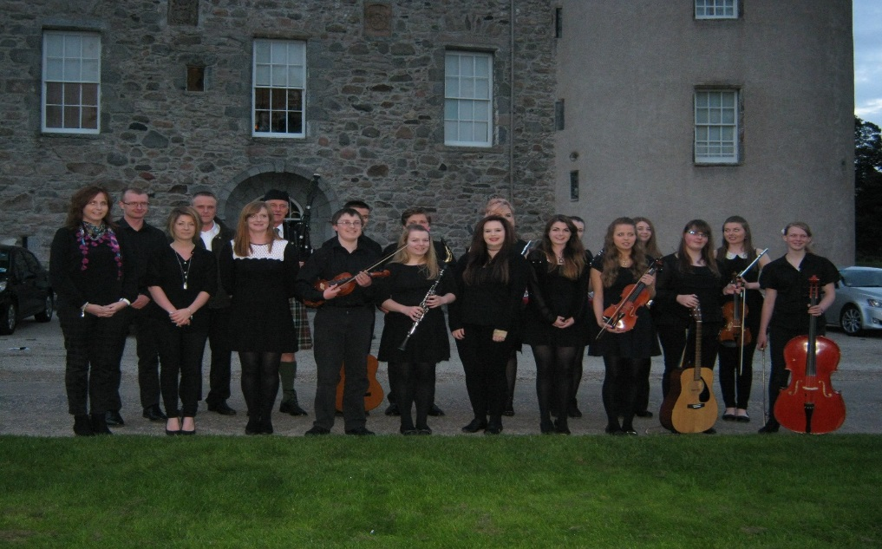

On Wednesday the 24th of September 2014 an S4/5/6 group of pupils who currently study music in the school were invited to perform at Castle Fraser for our 5th annual Evening of Music. The pupils who performed were; Alastair Fyfe, Jordan Ramsey, Rhianne Ross, Rachel Gray, Gaby Cortes, Ben Armstrong, Emma Thompson, Harrison Mowat, Iola Skinner, Iona Proud, Sophie Drysdale, Kirsty Smith and myself. There was a wide range of instruments played on the night, including Flute, Violin, Piano, Clarinet and Voice. The evening was a great opportunity for pupils to showcase their talents in front of an audience consisting of Family and staff members. The performances took place in the Great Hall which gave a wonderful atmosphere to play in and with the bagpipes to lead us in and the wonderful buffet afterwards in the dining room it truly was a memorable night. The evening was a huge success and everyone performed to an exceptionally high standard. All the musicians felt very proud to represent Inverurie Academy and showcase some of our amazing talent, at such a grand location.

Drama Trip to “In Time O Strife” - Gillian Gray S6

On the evening of 24th September, senior drama students and teachers ventured to the Beach Ballroom to see the play “In Time O Strife” by Joe Corrie and adapted by Graham McLaren for National Theatre Scotland.
The play was set during 1926 in Scotland’s Fife during the miners’ strike and subsequent ‘lock-out’ which brought many families to the brink of starvation as the church were also persuaded by the ’bosses’ to stop offering ‘parish relief’. McLaren’s reworking of the Corrie script was also filled with many references to the 1980’s strikes where the same themes of poverty and community breakdown were mirrored.
The story was based on one family’s struggle to survive the hardship brought about by the strikes and the lack of parish help. The atmosphere was further charged with the use of many of Joe Corrie’s moving poems like “I Am the Common Man” which were chanted in group choral style making them even more powerful.
On top of the brilliant acting and tear jerking poem’s the director and producer had cleverly integrated some very powerful contemporary dance but had done so in such a way that this added to, without overpowering, the story. The use of dance, song, the poetry and the proximity of cast/audience created a real impact in the audience as we felt the power of such raw emotions performed live.
I can honestly say, with my hand on my heart, that it was the best play I have ever seen and there were genuine tears during several heart-breaking moments in the performance
This play will form the basis of study in Section 2 of the Higher/Advanced Higher courses and study will continue in some depth for those classes from now till April next year. I have now been inspired to explore other ways of telling my own story in the Drama Skills component of my Nat5 course.

Rock Challenge – Olivia Landels S6

Rock Challenge is a dance/drama performance which originated in Australia and now takes place around the world. The core message is to achieve a natural high on life without the use of drugs, alcohol and tobacco.

We participated for our first time as a school last year in Rock Challenge 2014. Our team of 52 members did an amazing job and we brought home a total of 9 awards with our performance of ‘Near, Far, Whoever You Are’.

This year we have already created our concept, theme and ideas for our 2015 performance ‘Under Pressure’. We are on track to better ourselves and top last year’s show. With a full crew of over 130 people we have already raised a total of £4019.49 funding from our first sponsored silence event. Our next upcoming fundraiser is the Inverurie Rock Challenge quiz night due to take place on the 13th of November 2014. Thanks to the efforts of last year’s Rock Challenge Committee it was the most successful fundraising event we held in 2013 and we are very excited to host one again this year.

This year we want our school and local community to know about who we are, what we do and how they can support us. In order to do this we have set up a web page www.inverurierockchallenge.co.uk where you can find out more information. You can also support us by coming along to the event on the 27th of March 2015 – tickets will be available from ticket master nearer the time.

English Faculty – Ms Merchant, PT Faculty

As a new member of staff, I would like to take this opportunity to introduce myself. My name is Jill Merchant and I have taken over from Mr Cybulski as Principal Teacher of the English Faculty. Two classes studying National 5 English were given the chance to ask me some questions about myself.

- Which schools have you worked in before?

I have now worked in a number of schools. I began my career in Fife, at Buckhaven High School, where I worked for several years. I then moved back to Aberdeenshire to take up a new post at Turriff Academy. For the last three years, I have worked at Robert Gordon’s College, initially as an English teacher and then as Assistant Principal Teacher of the English Department. I was then delighted to be offered my current post at Inverurie Academy.

- What is the most important part of your job?

I would say that all parts of my job are very important but if I had to pick one aspect, it would be quite simple: providing the best possible education for my pupils. My priority lies in the classroom, ensuring that my pupils have the best possible chance of success in order to fulfil their potential.

- What’s your favourite word?

This is an interesting question and a very difficult one to answer! I would say my favourite word in the English classroom is onomatopoeia, simply because it is good fun setting your whole class the target of learning to spell it correctly!

- What is your favourite novel?

I find it really difficult to choose just one novel, so I will select my top three instead. My favourite novels are probably (1) ‘Great Expectations, (2) ‘Anna Karenina’ and (3) ‘Jane Eyre’ which makes it obvious that I most enjoy reading the classics.

- What can you bring to Inverurie Academy?

I’d like to think that I can bring a great deal of enthusiasm and passion regarding the importance of receiving the best possible education. As I’ve worked in a range of schools now, I also feel that I have diverse experience and ideas to bring to the English Department and Inverurie Academy as a whole. I look forward to immersing myself in the life of the school as I continue to settle into my new position.

Thank you for reading!

National Theatre Scotland Workshop - Lauren Thorpe S6

Prior to attending the NTS production of ‘In Time o’ Strife’, the assistant director, Andrew McGregor, spent an afternoon in our school preparing us for the themes and directorial concepts in this reworking of the Joe Corrie play.

The workshop was entertaining, insightful and memorable. After teaching us a series of warm-up exercises we were then given insight to how the play had been directed, and then got to ‘have a go’ ourselves. Andrew introduced us to a directing technique (based on the work of Stanislavski) called ‘Actioning’. This technique inspired and surprised everyone with its effectiveness in quickly producing very realistic performances, and will definitely be used by us in our own work as both directors and actors.
It was great to see the benefit of this technique in the gut-wrenchingly, emotional performance of ‘In Time O’ Strife’ later that same day. Fantastic!
.

A Uniform To Be Proud of – Mr Hamilton, Depute Rector

We believe that our students identify with the Academy by being proud to wear our school uniform. We welcome the support of parents and carers to ensure that our students have a smart appearance within the Academy and when they are out and about in the community. We are very pleased to report that our students are wearing uniform each day – we do check during registration and throughout the day and as students enter the hall for their morning assembly each week. Please consult the school website http://inverurie.aberdeenshire.sch.uk – Parents Area tab – General Information – Uniform, for a full description of the uniform. We have noticed a small number of students not wearing school uniform footwear. Footwear should be plain black this includes shoes, trainers or boots, exceptions will be made in very inclement weather. Blazers (optional for S4-6 students) were introduced to the uniform last session as a result of our regular review. It appears that the blazers currently available are not popular. As an alternative we have ordered Crests which can be sewn on to a black blazer of choice for those who wish to wear one. These will be available for purchase from the school office next term. We will let parents/carers and pupils know as soon as they are ready for purchase at the school office. November.

The Arms (Crest) of Inverurie Academy – Mr Hamilton, Depute Rector

We are exposed to it every day! More than once it may be added. Yet none of us probably take the time to look at it in any great detail and wonder how old it is, or why it came to be that way. It’s a bit like money; we see it every day and some of us are fortunate enough to handle it on a regular basis. But how many of us can say which famous person, other than the queen, appears on the back of a five, ten or twenty pound note?

What am I talking about? I am talking about the Inverurie Academy school crest of course. Like money we see it almost every day, but I am sure very few can confidently say what is actually on the badge. This article attempts to shed some light on the school crest i.e. how old it is, the symbols on the badge and finally, what it all means.

The Inverurie Academy badge was matriculated or registered with the office of the Lord of Lyon on the 4th April 1950. It appears in the “Public Register of all Arms and Bearings in Scotland”, which contains an official copy of every coat of arms granted in Scotland since 1672.

The motto of the school Spiritus Intus Alit appears under the badge. For those who are a bit rusty on their Latin, it translates to “The spirit within sustains”, and not, according to some folk, “a wee drappie inside keeps yer going”!

In an extract from the matriculation document, a heraldic description of the crest can be found:

Videlicit: parted per pale, dexter, or a fess chequy Argent and Azure between three open crowns; Gules; sinister, Azure, two castles in fess or, masoned sable, windows and portcullis Gules; on a chief per pale Azure and or, an open book proper between two quills in pale counter changed.

If your first language is not heraldic here is an explanation of some of the words that appear in the heraldic description:

Azure- Blue; Gules – Red; Sable- Black; Argent - Silver or Gold (all colours that appear in the badge) Pale- A band placed vertically in the middle of a shield; Fess- Horizontally; Chief – Upper part; Counter changed- Applied to a field.

If you look closely at the colour poster of the badge in your classroom you will see two quills in the upper part of the badge that shows that Inverurie Academy is a co-educational school for boys and girls. The lighter coloured quill represents the girls, and the darker quill the boys. The two are united through education, represented by the open book. The two towers on the right of the lower part represent the two ancient seats of power which protected the Garioch, namely the Mormaers of Mar and the Earls of the Garioch. The colours red and gold are the colours of the Earl of Garioch and blue and gold are those of Mar. The blue and silver chequered section, together with the three crowns, represent the arms of the Earl of Garioch. This also features on the arms of Alexander Stewart, husband of Isobel, Countess of Mar and Lady of Garioch.

I hope you now know more about the history of Inverurie Academy’s school crest. Now when anyone asks you about its history, you can enlighten them with your new found knowledge of the school crest.

You should be proud to be a student attending an Academy that has been educating boys and girls from the local area for over 110 years.

Remember our school motto Spiritus Intus Alit

Interhouse Golf - Fraser Yule 6C (School Golf Captain)

On Friday 19th Sept, five house teams of 3 players, took part in the first ever Interhouse golf competition at Inverurie Golf Club. The format was a Texas Scramble. There was some high quality golf played and in the end Davah narrowly came out victorious ahead of Crichie. The longest drive contest at the 16th was won by Ben “Bubba” Green and Finlay Watson was closest to the pin at the 10th.
Results:
Davah 64.3, Crichie 64.8, Harlaw 66.2, Barra 72.9, Selbie 86.4

Ryder Cup Trip - Jamie Falconer 4C

On Wednesday 24th September, a group of 28 pupils and 2 teachers travelled down to Gleneagles Golf Course to watch Team Europe and Team USA on the second practice day of the Ryder Cup 2104. Team USA had an early start on the course at 0930 and Team Europe went out at 1100 starting on hole 9. We were able to watch all the professionals in action on the course and saw many of them going through their routines on the practice area. Some of us were lucky enough to collect autographs and take photos. It was an amazing experience to see the world’s number one, Rory McIlroy, as well as all the other well known golfers. In the afternoon we watched the Junior Ryder Cup Friendship Match with the prospective stars of the future. As well as watching golf there was time to look round the spectator village where there were various activities to join in, shops selling Ryder Cup merchandise, a BMW display, live bands on stage and food stalls. The sun shone and we had a very memorable day.

Ms Lee Menzies, Depute Rector

I am delighted to have taken up the post of Depute Rector here at Inverurie Academy. I can't believe that term one is nearly over.

As S4 year head I have been very impressed by the way the pupils have settled into their new courses and how serious most are taking their learning. As part of the comprehensive assembly programme, I have led assemblies on the use of Tracking, Monitoring, Reporting and the intervention strategies to help pupils 'be the very best ' that they can.

S1 pupils have also settled in well to the new term and have recently been involved in sitting standardised assessments (MiDYIS) which will help us to identify areas of strength and development.

I have been involved in discussions with all Faculties looking at how well our pupils have done in their recent SQA exams.

It was good to meet colleagues from our cluster primary schools and I am very much looking forward to working with colleagues across the network to ensure a smooth transition for pupils transferring form P7 in S1

The highlight of my time here so far has to be the music recitals by our senior pupils at Castle Fraser - wow what a talented bunch !

As the year goes on, I am looking forward to getting to know and work with staff, pupils and parents and would like to thank all who have made me so welcome in the past few weeks.

Planning for University - Matt Smith6C

In July I went to Strathclyde for 5 days to take part in a Headstart Course entitled Introduction to Engineering. We stayed in University accommodation for the week. There were 40 of us on the course, mostly from England, some from Scotland with two boys from Nigeria. We were divided into different groups for the different tasks we did during the week. One project was trying to move a hand built boat using only the momentum of a falling brick. We were also shown around many of the other science departments during the week.
One of the helpers introduced himself as a rocket scientist because during his PhD he had worked on the design of the parachute for the Mars Rover.
There were a lot of social events organised during the evenings, a trip to the cinema and a restaurant meal close by because the university is in the middle of Glasgow.
At the end of the week, I had decided I definitely wanted to go to Strathclyde, perhaps to do astronomy or astrophysics. I would recommend the Headstart Course to other people starting S5 who are interested in science.

Adverse Weather – Mrs Morrell, Support Services Co-ordinator

As we prepare for the winter term and potentially adverse weather that may
bring disruption to the school day – we would like to remind you of the various
options for finding out whether or not the school is open or closed in such
circumstances.

- The Telephone Information Line number is 0870 054 4999. You will be asked
for the school PIN number. It is 021060. Once the PIN number is entered, simply
follow the instructions (you need a push pad telephone to do so). During bad weather information will be updated each evening at about 6.00pm, or as appropriate.

- The Website is www.aberdeenshire.gov.uk/closures . The website is easy to use and
the information will be updated at regular intervals as appropriate.

- Local Radio Stations will announce closures .The website is linked to local radio stations
and when the school updates a message on the site it is automatically e-mailed to them.

Dates for your diary

Monday 27 October | Term 2 begins
Monday 03 November | Skills Scotland event at AECC (selected S4/5/6pupils)
Thursday 06 November | UKMT Senior Maths Challenge
Monday 17 November | In-Service
Tuesday 18 November | In-Service
Wednesday 19 November | In-Service
Thursday 20 November | School Photographer (Groups)
Friday 28 November | S5/6 Interim Reports Issued
Wednesday 03 December | Panto Trip (S1-S3)
Thursday 04 December | S5/S6 Parents Evening (4.30 - 7pm)
Friday 05 December | Talent Show
Wednesday 17 December | S4 Interim Reports issued School Christmas Concert 7 .30 p.m.
CHRISTMAS HOLIDAYS : Monday 22 December - Friday 2 January

