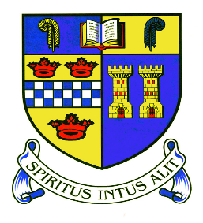



Newsletter 2014

**Winter weather – Ms L Evans**

When adverse weather conditions present a potential threat to the normal opening on Inverurie Academy a number of procedures are implemented to make decisions both on the running of school transport and whether or not, or to what extent, the school will open.

If conditions are very poor the transport operators may make their decision the evening before. Other contractors either call us or we call them around 6a.m. By this time a number of operators have already been out driving the bus routes to determine their safety. We also take account of a special Aberdeenshire Council Roads department forecast, Traffic Scotland road reports, police reports and various weather forecasts. A member of our janitorial team is on site from 6a.m. an can give us a report on the conditions around the school. When we have all this information a decision is made and we post the notice on the Aberdeenshire Council School Closure website and on the phone line. Every attempt is made to do this by 6.45a.m. These bulletins are updated immediately we are informed of any change to transport or circumstances.

You can keep up to date with the website by subscribing to the School Closures RSS feed or following Aberdeenshire Council on Twitter. Links to these are on the closure website.

**The Website** is  [www.aberdeenshire.gov.uk](http://www.aberdeenshire.gov.uk/)/closures

**The Telephone Information Line** number is **0870 054 4999.**  You will be asked for the school PIN number.  It is **021060.**

Given that we are extremely busy communicating with transport providers and staff who are update us on their progress to school it is extremely helpful if you use either of the services above for information on the status of school transport and opening and avoid calling the school office directly.

Teachers will have informed pupils of work that can be done if they cannot get to school and we will use ‘Show My Homework’ sand Glow for this too. Pupils will be asked to check their glow passwords etc at the start of term and given the chance to refresh these – just in case! Senior Students will also be able to make use of the Scholar website. The support and encouragement of parents/carers in ensuring that pupils work at home to minimise any time lost through adverse weather is greatly appreciated by teachers in the school.

**Show My Homework – Mrs P Fraser, Depute Rector**

This term, all pupils have been issued letters with their Show My Homework log-ins and a log-in code for parents/carers. We hope you are finding this to be a useful tool to help you support your child with their homework. Parents/carers and pupils can change the log-in code to something more memorable once you have logged into the system by clicking on the settings button.

**Achievement Record Slips – Mrs P Fraser, Depute Rector**

Many of these slips have been completed by our young people in school for a whole variety of achievements this term. Please remember that parents/carers can also complete these to inform us of your child’s achievements via the form in the parent communication area of the school website.

**Music at Victorian Market. : Fiona Rae S3**

On the 23rd of November Inverurie Academy’s music pupils performed at the Victorian Market in the Inverurie town hall we had three groups performing the singers who are going on our Italy music tour in 2015, Celtacad who are also going and the flute ensemble.

I think the public enjoyed our pieces of music which we played and sang just as much as we loved performing them. We were also joined by a group of talented highland dancers. As well as being able to watch and listen to the music and dancing, the public also got to look at the products different stalls had to offer such as clothes, decorations and food which most of the pupils enjoyed doing as well as the public. Over all it was a good day for all of us and the pupils are looking forward to the Christmas concert on the 17th of December at 7:30 in the school hall

Big thanks to Mrs Moggach, Mrs Tierney, Miss Conn and Miss Cook for helping us get to the standard we perform at today and helping behind the scenes as well as on stage.

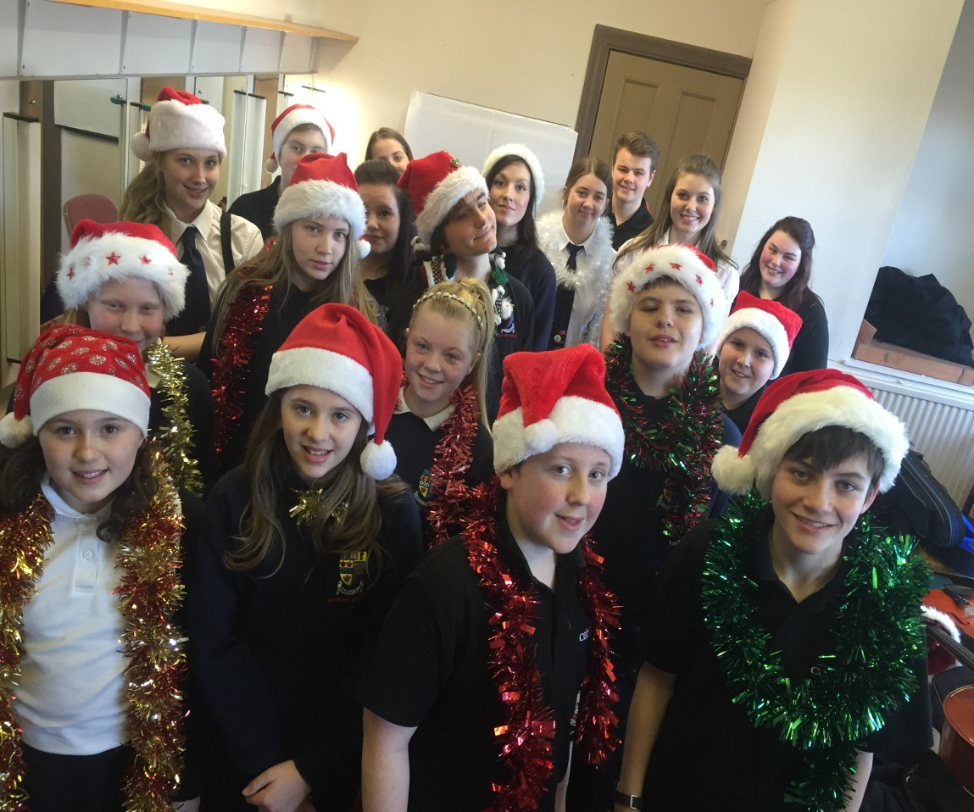

**Kellockbank – Kyle Taylor S3**

On Sunday the 7th of December, Inverurie academy’s music groups visited Kellockbank to preform to the public. The brass group, singers and Celtacad all preformed. They raised a total of £150.73 for the Italy tour which is in 2015.

All of the performers played well and it was the brass ensemble’s first time performing in public. All of the performers are excited to perform in the Christmas concert which we are working towards. Big thanks to Mrs Tierney, Miss Cook, Miss Conn and Mrs Moggach for helping behind the scenes and with performances. The public were very impressed at the talent at Inverurie academy and occasionally joined in with the carols if they know the words. The money that we raised was much appreciated and will be help towards the funds of the Italy trip

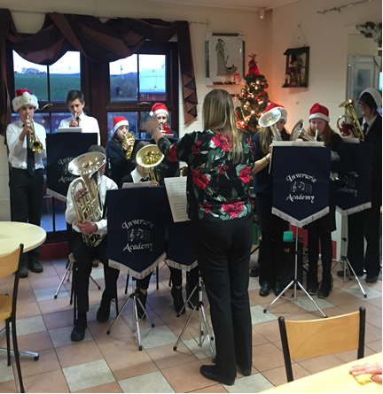

**Christmas Concert – Iona Proud S6**

The annual Christmas concert will take place [at 7:30 on the 17th](x-apple-data-detectors://0) December. The highly anticipated event will feature most of our talented music groups including The Orchestra, Concert band, our various choirs as well as our ceilidh band Celtacad. It has been a busy term for the music department who have performed various gigs at different venues as well as preparing for the Italy Tour this summer. Rehearsals have been ongoing throughout this term in preparation for the concert which we are sure will be a resounding success. Thank you to all pupils and instructors for all the hard work put in to make the event possible. 

**Rotary Young Musician of the Year Competition - Polly Turner S2**

The Rotary Young Musician of the Year Competition took place on Wednesday 12th  November this year, in the Assembly Hall. For this competition, the entrants perform in front of parents, members of the Rotary Club and the judges.

I received the letter a few weeks before, and decided to take part, mostly for the sake of playing on the grand piano. The piano I practise on at home is electronic, and has a broken E', which is often frustrating.

My parents first began teaching me how to play the piano when I was four years old. I don't take formal lessons, so my mum will teach me a piece of music, and then I'll learn it off by heart and improve on it myself. I think this allows you to concentrate on the music more, and make it more expressive. Besides, it's tiresome having to carry music sheets around the whole time.

Ever since I advanced beyond the limits of 'Mary had a Little Lamb', I had felt a strong attraction to classical music. Because of this, I had decided to play Prelude no. 1 and Fugue no. 2, by J.S. Bach. Both have 'sentimental value' for me and contrast with each other.

This year there were seven entrants to the competition: four pianists, a cellist, a violinist and a vocalist. Since there was only one Senior performing, it was a bit pointless picking winners for both Junior and Senior sections, so the judges decided to just choose the overall winner from all the performers. To be honest, I was not expecting to win at all! In joint second place came Gillian, the only vocalist, and Euan on the piano.

I will perform again at the Rotary Club in February (being paid with dinner) and will go forward to the District final in Perth, later in March. I've already decided what to play, and am looking forward to taking part in it.

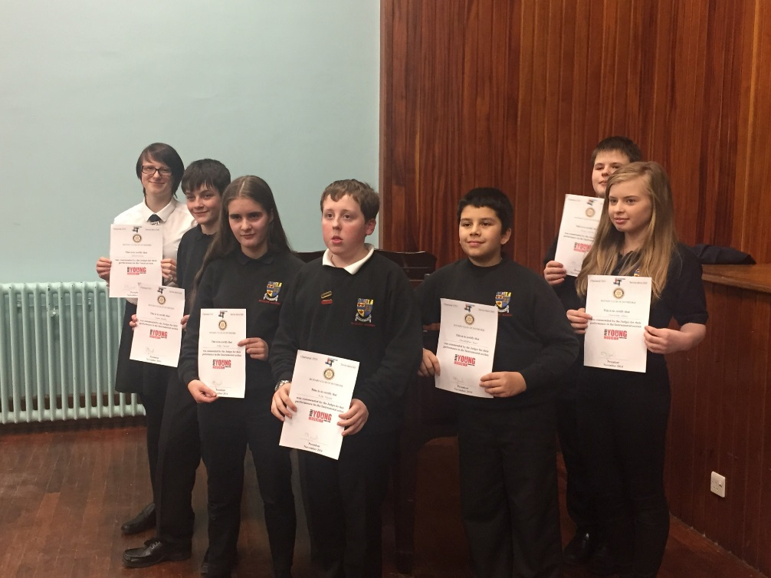

**Acorn Centre - Beth Strachan and Gaby Cortes, S6**.

On the weeks beginning 1st and the 8th of December 2014 an S4/5/6 group of pupils who currently study music in the school were invited to play at the Acorn centre in Inverurie during several lunchtimes, to the delight of the diners in the café. The pupils who performed were; Niamh Lawrie on guitar; Iola Skinner on Piano; Rachel Gray on Cello; Ben Armstrong Saxophone; Beth Strachan on flute and Piano; Gaby Cortes on Flute and Saxophone; Kirsty Smith on Flute; Iona Proud on Piano; Rhianne Ross on Piano; Jordan Ramsey with voice and Alistair Fyfe on fiddle. This invitation was a great opportunity for pupils to practise their performance skills in front of an audience before their exams. It was an excellent chance to showcase the amazing talent Inverurie Academy has to offer and all of the pupils felt proud to represent their school.

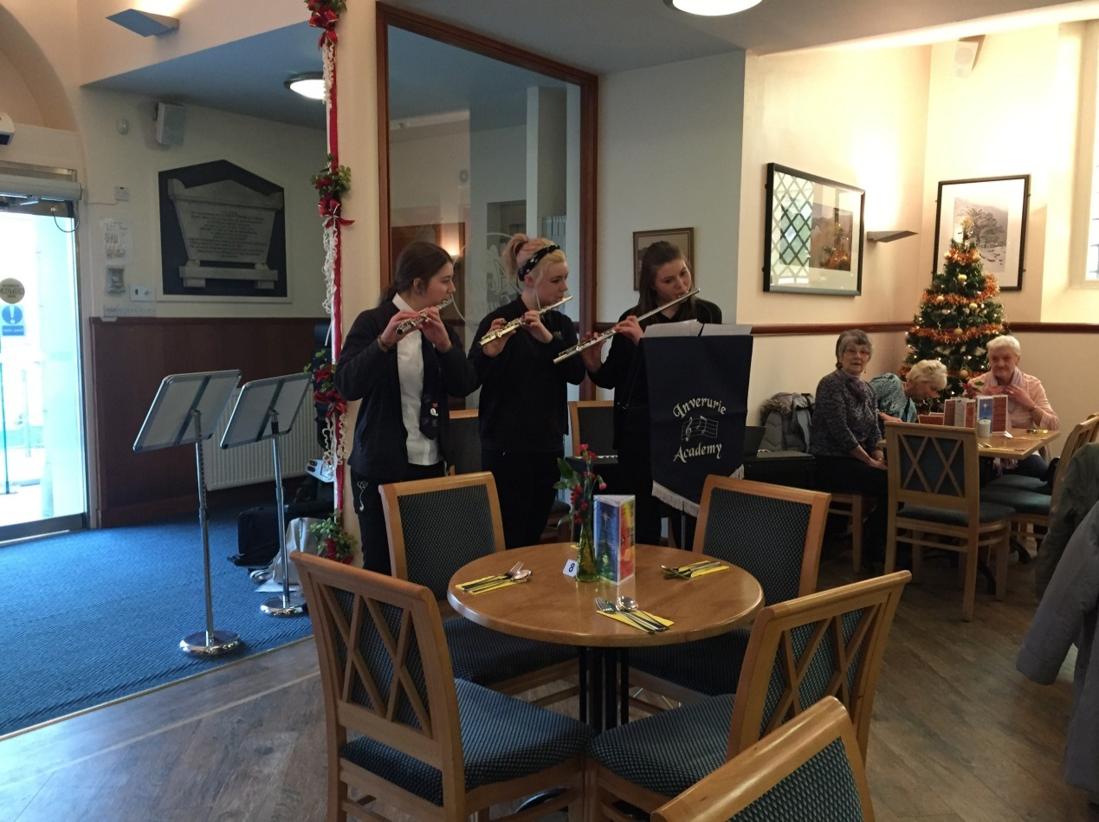

**Young Enterprise – Mrs Taylor, Link Teacher – Young Enterprise**

Another year, another Chrismtas fayre…or two! The Young Enterprise Company Programme at Inverurie has again had 4 teams this year. They have been hard at work since August creating a product and getting ready to sell at two Young Enterprise Christmas fayres which were held in Westhill and the Bon Accord Centre at the end of November. All teams were successful and had a great time (if a little tired!).

RePLAY produced clocks, coasters and Christmas tree decorations made from parts of old games.

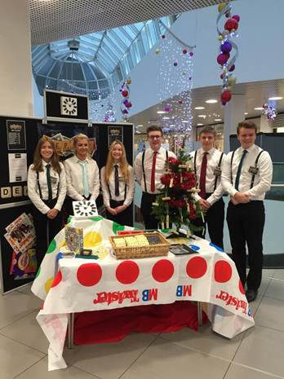

MIXJAR produced homebaking kits (Chocolate brownie, gingerbread loaf, white chocolate and cranberry cookies – all of which are YUMMY! I had to be part of the taste testing teamJ).

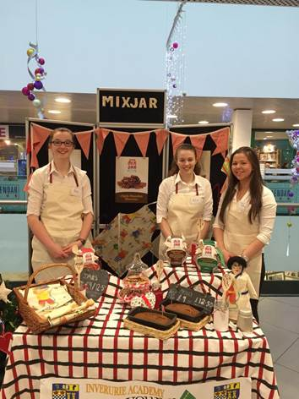

Trepall made wooden signs and advent calendars made from old wooden pallets.

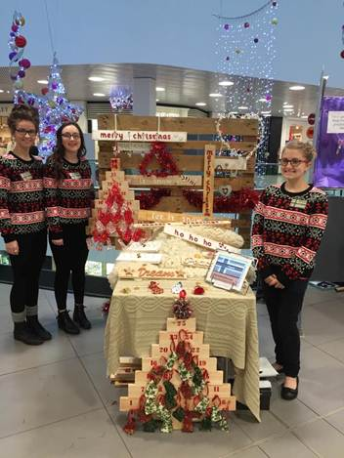

Top Glass produced serving dishes made from flattened glass bottles and Christmas displays made from glass bottles.

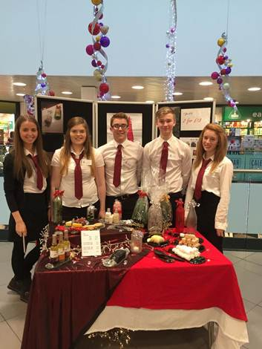

All the teams have learned a lot about how to run a company, how to work as part of a team and how to communicate with the public. As always, it has been a great experience. Now all the teams have to decide whether to continue their company and enter the competition to be Young Enterprise Grampian’s Company of the Year. Watch this space.

**Achievement – Joseph Miley S6**

Months before the first day of the commonwealth games I knew that my sister was capable of winning gold. Every morning she wales up earlier than the rest of us in order to plan her day of straining. She knows how to improve each component of her individual sport. As a sport, swimming is not an easy choice; but watching Hannah being so focused and driven, motivates my brother and I. To know that a two time Olympian and a commonwealth champion lives under the same roof as me is astonishing, even more so knowing she’s my sister. If it wasn’t for her I don’t think I would be swimming the same way as I do today, all my achievements are in credit to her, from doing my first personal best times to me most recent accomplishment of winning sliver at the UK School Games, representing my country and school. I tend to be known in school just as ‘Hannah Miley’s brother’, this used to really upset me in the earlier years, but I’ve been able to move on from that and take it as a positive, knowing that it drives me and makes me want to achieve my goals more just to prove all of them wrong. I owe a lot to my sister, not only for inspiring me, but also for giving me the confidence to know what it takes to get to her level of performance. She is a great role model and a real inspiration to all of the family. Living in the same house and being part of what she does is a unique experience and I know that she has inspired me to chase my dream just like she has chased and caught hers.

**Inverurie Academy Parent Council - Mr J MacGregor**

Further to the recently distributed report to the Parent Forum, we welcome all parents and carers of pupils at Inverurie Academy to attend any of our meetings.

To contact IAPC:

<http://inverurie.aberdeenshire.sch.uk/parent-council/>

Facebook – ‘Parent Forum Inverurie Academy’

**BP Work Experience : Isaac Bacon S3**

On the 8th to the 11th of December, a lucky few of only thirteen of the eighty-three applicants , received a guaranteed work placement, working beside Scotland's top oil and gas engineers within the BP Head Quarters situated in Dyce. Only three from Inverurie Academy were given a place, Shaun Duncan in S3 Craig in S4 and myself, Isaac Bacon in S3. To begin the placement, we were all given a reasonably short health and safety briefing. After this, came icebreaking and team building activities, in which we were given the challenge to build a drilling jacket from marshmallows and straws. Shortly afterwards, we received light refreshments and then were taken straight off to a small conference room in which we learnt the complexities of locating and drilling for oil.

During the second day we were all appointed a personal engineer, according to our engineering aspirations, to shadow for the day and learn a little more about the specifics of their chosen field. There was a vast variety of specialists and mine, was fortunately, a Mechanical Engineer.

We were introduced and almost immediately began work. Throughout the day, my brain was drummed with the mechanics of Gas Turbines, combustion engines and the pressurising of the accommodation blocks on the oil platforms. Even though this was what felt like only a short day, I was massively inspired by my engineer's work and capabilities within their field.

On the second last day we all had a surprise in store. This was a trip to Bond Helicopters, which is where the companies engineers travel from to get to their designated oil platforms. Meetings with the aeronautical engineers and pilots had all been arranged, making it a fascinating and extremely rare experience.

The last day was occupied by interview and CV writing skills; an extraordinarily valuable workshop. Then after a small break, an opportunity to speak, via webcam, to engineers working offshore arose. This was a brilliant chance to hear what it was like to actually commute to, and work on, an oil rig. Then it was time to give a short presentation on what we had learned during the work placement, and what we would take away from the experience. Now, sadly, our placement had ended and saying goodbyes to our peers and the engineers that had mentored us for the week it, was time to go.

**ICELAND TRIP: OCTOBER 2014 - Leanne Anderson S4**

On the 12th October this year a group of eighteen pupils, along with Mr Shepherd and Ms Walker, went on a school trip to Iceland. We flew there by plane and soon arrived in Keflavik Airport where we met our bus and bus driver for the week. We then started our journey to our first destination, the Blue Lagoon. It’s a natural lagoon and formed from geothermal seawater, its aquamarine in appearance and provides a source of minerals known for therapeutic properties, it also has an average temperature of 37°C, so it was very relaxing! After spending awhile there we then departed to our first hotel, the Hotel Cabin in Reykjavik.

The next morning we were up early and off to our next destination, Thingvellir National Park, where the rift between the North American and Eurasian Plates is the most obvious, and you can actually walk through it as well. After exploring the national park we then left for Geysir. The Strokkur Geyser was the most active there, erupting every 5 minutes and the height of the water reaching 15 metres! Our final journey that day took us to Gullfoss, also known as The Golden Waterfall. It’s Iceland’s most famous waterfall and has a drop of 32 metres into a small canyon below which has a depth of 70 metres and you can see a rainbow coming out of the waterfall also!

The next few days we were up early again to visit more spectacular sites over the country which includes two other waterfalls one of which you were able to walk behind it and the other had a legend that a settler had once buried his gold at the base of the waterfall, but in the weather conditions there was, I don’t think anyone was prepared to go and look for it! That evening we arrived at our new hotel we were staying in, Fosshotel in Skaftafell which was right on the doorstep of a gigantic glacier and Skaftafell National Park, which was where we went the next day to get a guided talk with a ranger about the area and walk up around the park to get great views of the waterfalls and a glacier called Svinafellsjokull.

My favourite part of the trip came next, we drove to Jokulsarlon and took the boat trip into the lake which contains the ice and debris deposits of the glaciers. We got to taste parts of the icebergs floating around which contained water which was thousands of years old. Jokulsarlon was also the site of films including the James Bond film Die Another Day, Tomb Raider and Batman Begins.

The next day we set off for Reynishverfi to see the basalt columns on the cliff faces, these were right next to a beach which had black sand instead of yellow, humongous waves and as you can imagine, it was freezing! But no sooner had we got on the bus and thawed out, we arrived at our next site of Hveragerdi Geothermal Park where we explored for a bit and then went for a swim in the outdoor swimming pool. After this we departed for the Hotel Cabin once again, stayed for one last night and then got up extremely early the next morning to catch our flight home. This trip to Iceland was extremely fun and eventful! But I would definitely go again if I got the chance!

**Leadership in Sport : Ms Lynch, Depute Rector**

Since summer, 37 keen fourth, fifth and sixth year pupils from Inverurie Academy have embarked on various leadership training opportunities. The leadership training, which included Dance Leaders, Sports Leaders, Young Ambassadors, Netball Leaders, Scottish Football Association Youth Development and Early Touches has been delivered by our Active Schools team, as well as external agencies, where pupils have gained awards and national governing body qualifications.

Many of these opportunities were offered to pupils across Garioch, which included Inverurie, Kemnay and Westhill Academy. The pupils teamed together for full days and evening training sessions, which covered a number of competencies, including communication skills for sport, taking control of a group, organisation, adaptation and delivery of small activity sessions. As well as meeting new friends from other schools, pupils also gained valuable experience, knowledge and confidence throughout the sessions.

The leadership courses provided pupils with the vital tools to prepare them for their journey ahead which will take them volunteering for the academy, local primary schools and into the community.

Well done guys!!

Ashley and Iona – Netball Leaders and run the netball club

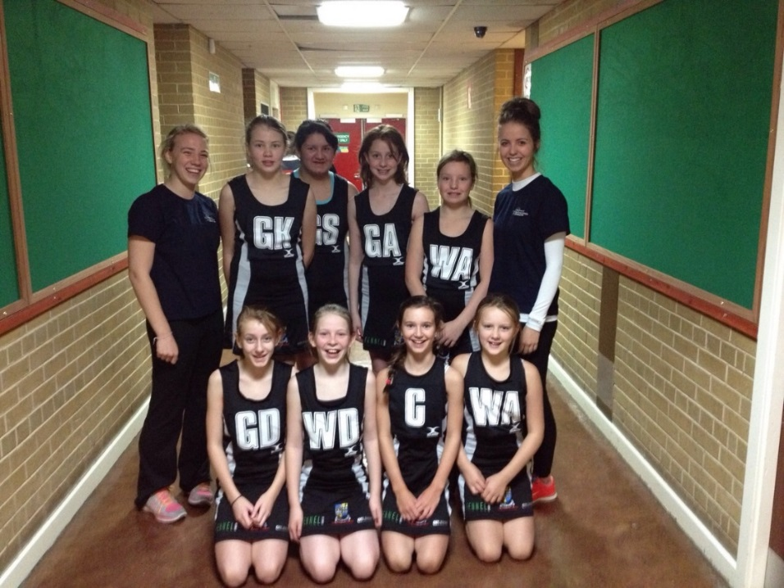

Dance Leaders – Help support the Rock Challenge club and will be delivering sessions to primary schools in term 3.

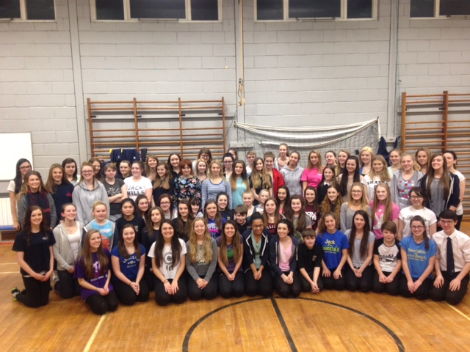

Sports Leaders – Help support after school and lunch time clubs

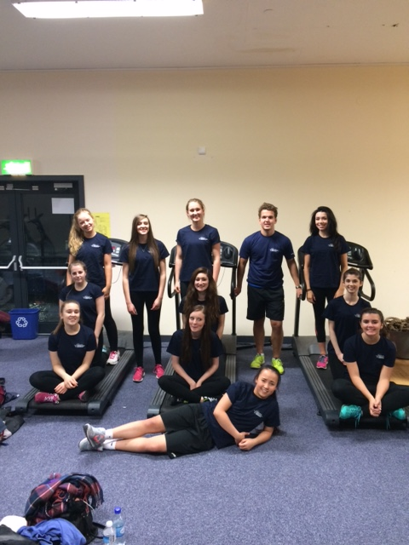

Young Ambassadors – Motivate and inspire other young people to participate in sport & physical activity, are positive role models, who reflect views of other pupils and influence and shape decision making in sport.

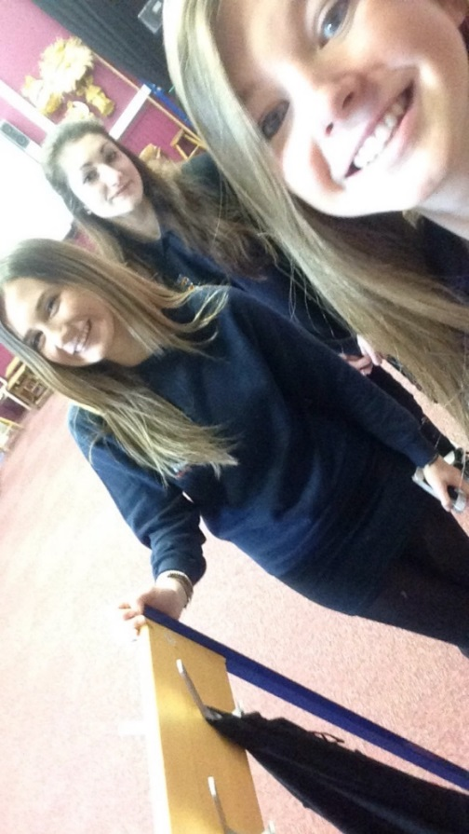

SFA Football Coaches

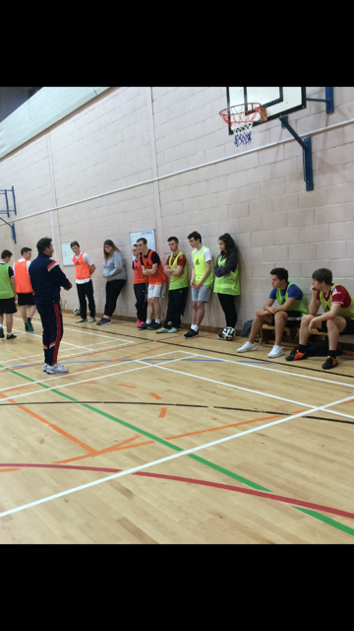

**And finally…**

I am convinced that schools have their own ‘seasons’ – a rhythm and pace to school life that makes each term different. This terms ends with our traditional Christmas concert, showcasing so many of our talented pupils - not only those who perform but also those who work behind scenes, in lighting, sound, publicity etc. This fabulous concert never fails to get us in the Christmas mood and sets us up well for the holiday season.

On behalf of all the staff and pupils of Inverurie Academy I hope that you have a very Merry Christmas and a Happy New Year.

Best Wishes

**Linda Evans**

**Rector**

|  |  |
| --- | --- |
| **CHRISTMAS HOLIDAYS : Monday 22 December - Friday 2 January** | |
|  |  |
| **January 2015** | |
| Monday 05 January | Term 3 |
| Thursday 15 January | S4 Parents' Evening (4.30pm - 7pm) |
| Monday 19 January | DTP and Men.C -S3 girls |
| Wednesday 21 January | S2 Parents' Information Evening (6.30pm) |
| Friday 23 January | Publication of Senior Phase Choice Booklet |
| Monday 26 January | Start of S4/S5/S6 Assessment period  S2 Personalisation Booklets issued during PSE |
| Wednesday 04 February | S3 Reports Issued |
| Thursday 05 February | UKMT Intermediate Maths Challenge/ S3 Parents' Information Evening (6.30 pm) |
| Friday 06 February | Last day of S4/5/6 Assessment Period |
| Wednesday 11 February | S3 Parents' Evening (4.30 - 7pm)  Start of present S3 Choice Interviews |
| Friday 13 February | Occasional Holiday |
| Monday 16 February | Mid Term Holiday |
| Tuesday 17 February | In - Service |
| Wednesday 18 February | In - Service |
| Thursday 19 February | S4/S5 Parents Information Evening (6.30 pm) |
| Monday 23 February | MMR catch up for S3 girls |
| Thursday 26 February | P7 Parents Information Evening (6.30 pm) |
| Thursday 05 March | World Book Day |
| Monday 09 March | S4/S5/S6 Reports Issued |
| Tuesday 10 March | Start of S4/S5 Subject Choice Interviews |
| Thursday 12 March | Careers Evening (7 - 9pm) |
| Tuesday 17 March | S3 Youth and Philanthropy Final evening |
| Monday 23 March | 3rd HPV S2 girls |
| Wednesday 25 March | S2 Reports Issued  Creative Arts Showcase 5-7 p.m. |
| Tuesday 31 March | S2 Parents' Evening (4.30pm - 7pm) |
| Wednesday 01 April | Final Date for submission of S2 Personalisation Forms |
| Friday 03 April | Holiday |
|  |  |
| **EASTER HOLIDAYS : Friday 03 April - Friday 17 April** | |